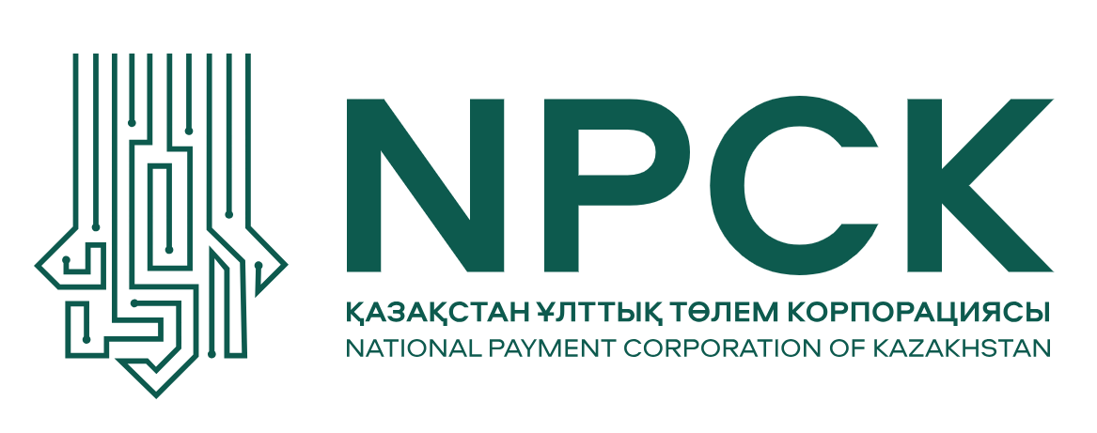

Press release
Almaty January 9, 2026
Changes to the Composition of the Board of Directors of the National Payment Corporation
An updated Board of Directors has been formed at the National Payment Corporation of Kazakhstan. The new members include Erlan Ashykbekov and Askar Zhambakin. Their appointment strengthens the NPC’s strategic expertise in the development of payment infrastructure, digital technologies, and corporate governance.
The key objective of the Board’s renewal is to reinforce the Corporation’s focus on innovation and the sustainable development of the national payment system. Amid rapid economic digitalization, it is particularly important that payment solutions become even faster, more convenient, and more secure. The updated Board of Directors of the NPC will focus on the implementation of advanced payment technologies, the development of digital services, the protection of customers against fraud, and the expansion of cashless payment opportunities for both individuals and businesses.
“Our goal is to build a reliable, technology-driven, and accessible payment ecosystem capable of meeting future challenges and supporting the country’s economic development. We are strengthening our focus on innovation, including the application of artificial intelligence–based solutions, as well as on the development of intelligent payment management and security systems. This is precisely why the Board has been joined by experts with a deep understanding of the market and extensive hands-on experience in delivering complex infrastructure projects,” said Binur Zhalenov, Chairman of the Board of Directors of the National Payment Corporation.
“For the National Payment Corporation, it is particularly important to build an open and professional dialogue with financial market participants, as well as with external experts and counterparties. The updated composition of the Board of Directors strengthens this engagement and enables a more comprehensive approach to the development of payment infrastructure,” emphasized Zhanar Samayeva, Chairwoman of the Management Board of the National Payment Corporation.
The updated Board of Directors will continue to advance the national payment infrastructure and strengthen the role of the NPC as a key participant in Kazakhstan’s financial market—reliable, technology-driven, and customer-focused.
Erlan Ashykbekov is one of the leading experts in payment systems and financial technologies. His professional background is closely linked to the development of payment infrastructure, the introduction of advanced digital services, and the enhancement of the security of cashless transactions. His substantial experience in improving payment mechanisms and interbank cooperation will contribute to the development and establishment of new market standards.
Askar Zhambakin is an executive with many years of experience in the corporate sector and in the strategic development of large companies. He specializes in business process efficiency, sustainable growth, and the implementation of digital innovations. His participation on the Board of Directors will support the further strengthening of the corporate governance framework and the implementation of long-term strategic digitalization initiatives.
Askar Smagulov will continue his work as a member of the Board of Directors. He has extensive experience working with financial market organizations, with a strong focus on the development of corporate governance and the formulation of long-term growth strategies. His expertise is associated with the development of corporate structures, investment activities, and the management of large-scale assets, including in the retail and real estate development sectors.
More detailed information about the members of the Board of Directors and the activities of the National Payment Corporation is available on the official website.
The National Payment Corporation expresses its gratitude to Petr Trabinsky and Keith Gaebel for their productive work on the Board of Directors, their demonstrated responsibility, and expert approach, and wishes them every success in their future professional endeavors.

For more detailed information, media representatives may contact
us by phone at: +7 (775) 84-66-814.
Akmayev.D@npck.kz

